**Figure A. Import the data into SAS cloud Directory**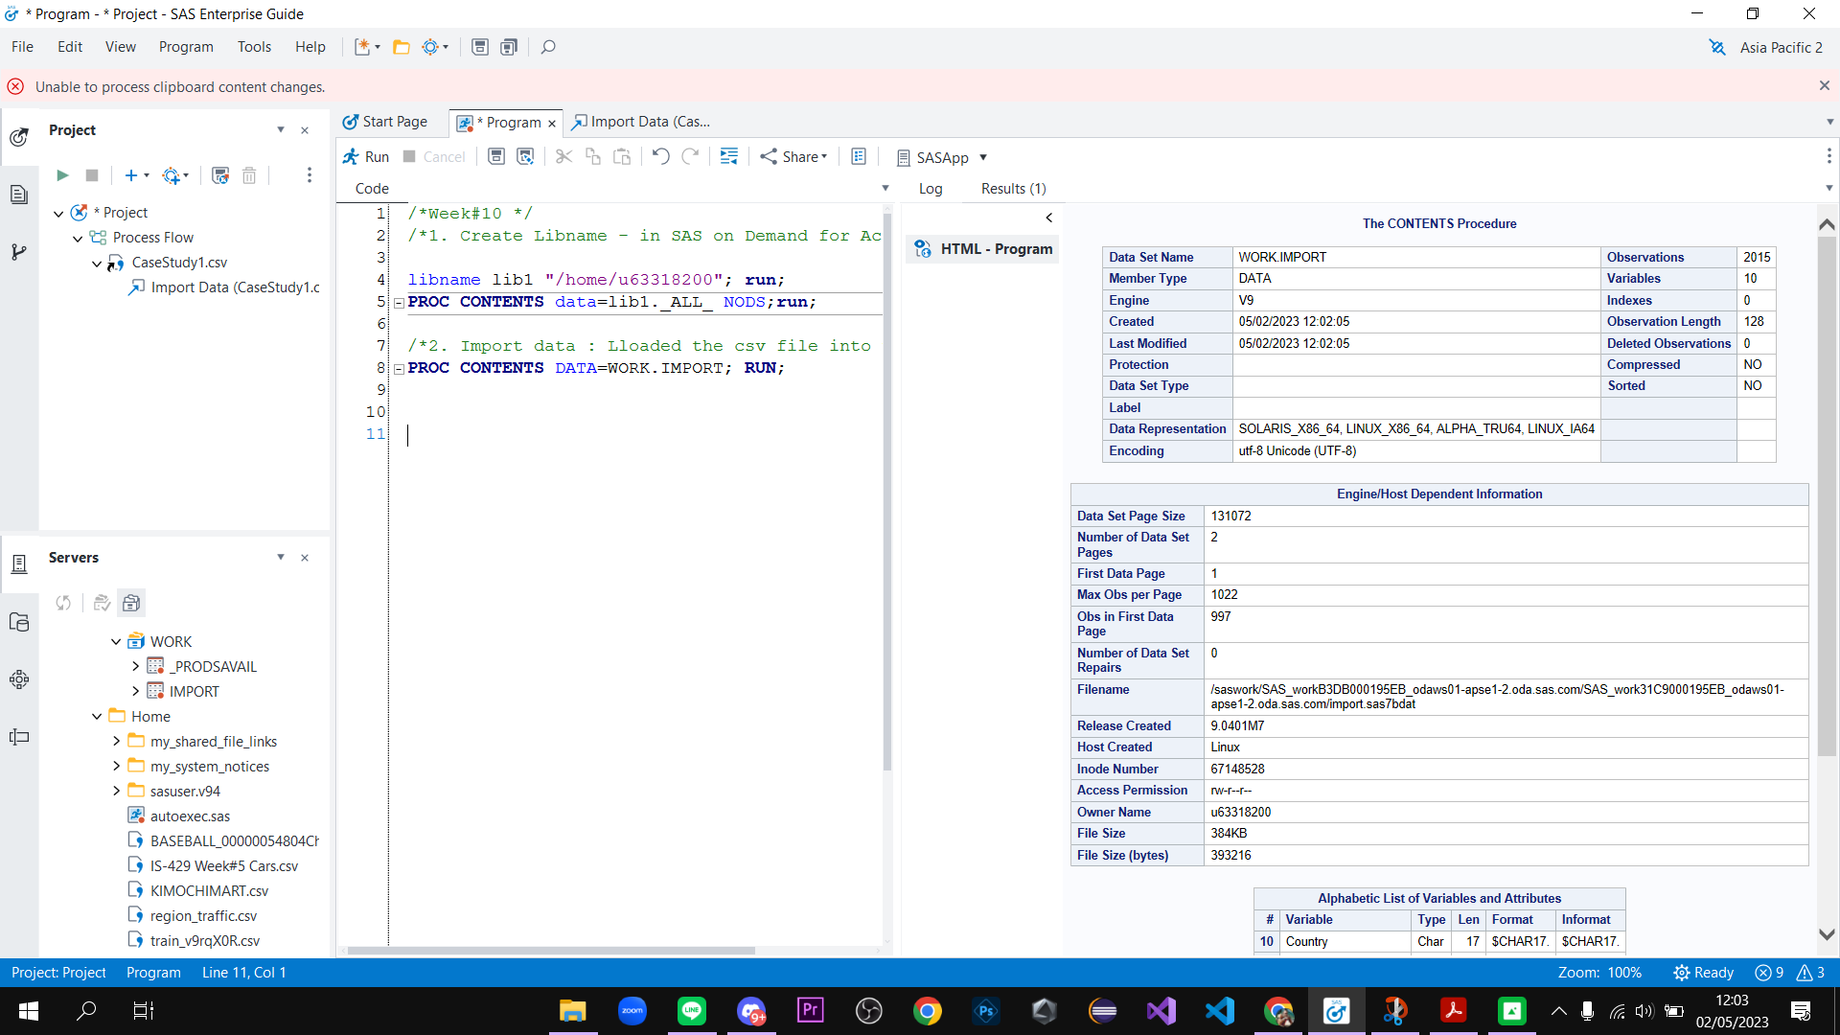

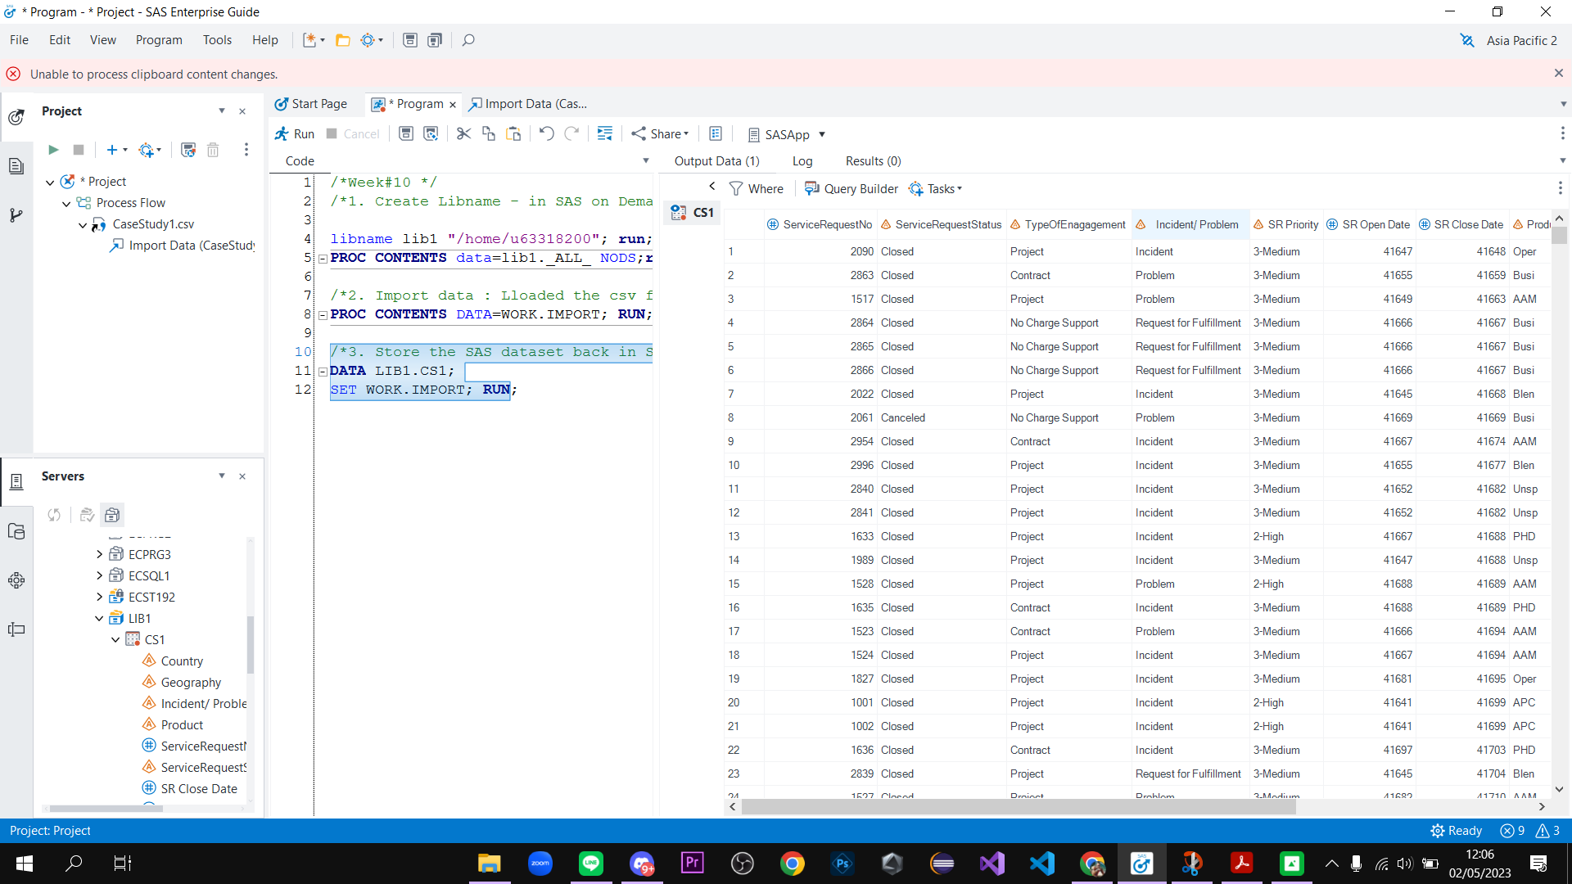

**Figure B. Store the SAS data set back in the SAS cloud library.**

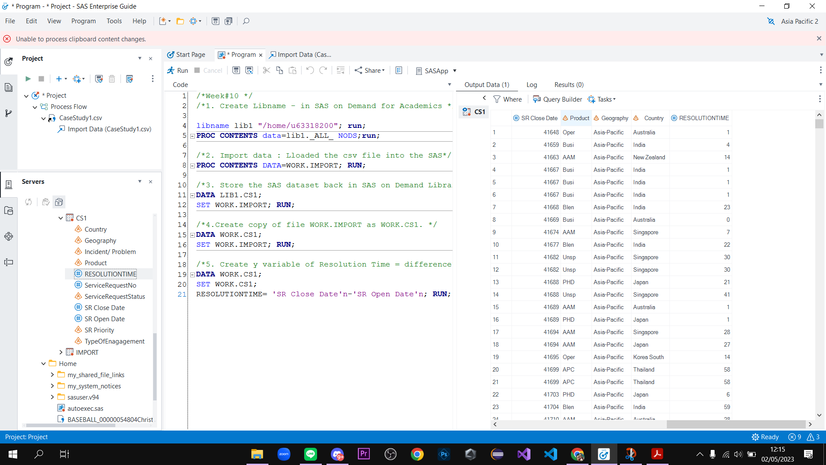

**Figure C. Define the problem: Clean the data to resolve the SR**

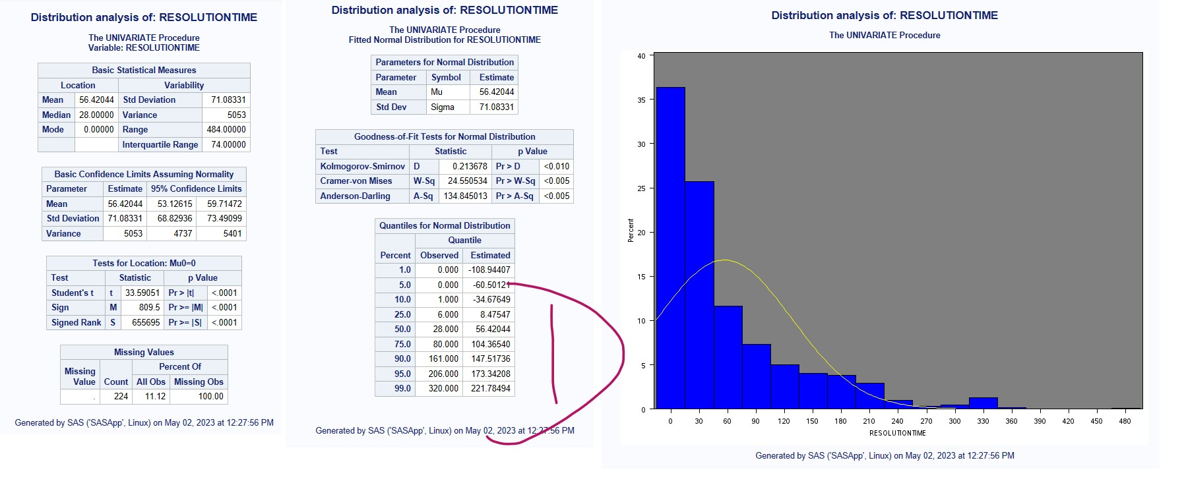

**D. Analyze, Visualize, and get Insights: Understand the distribution of the y variable**

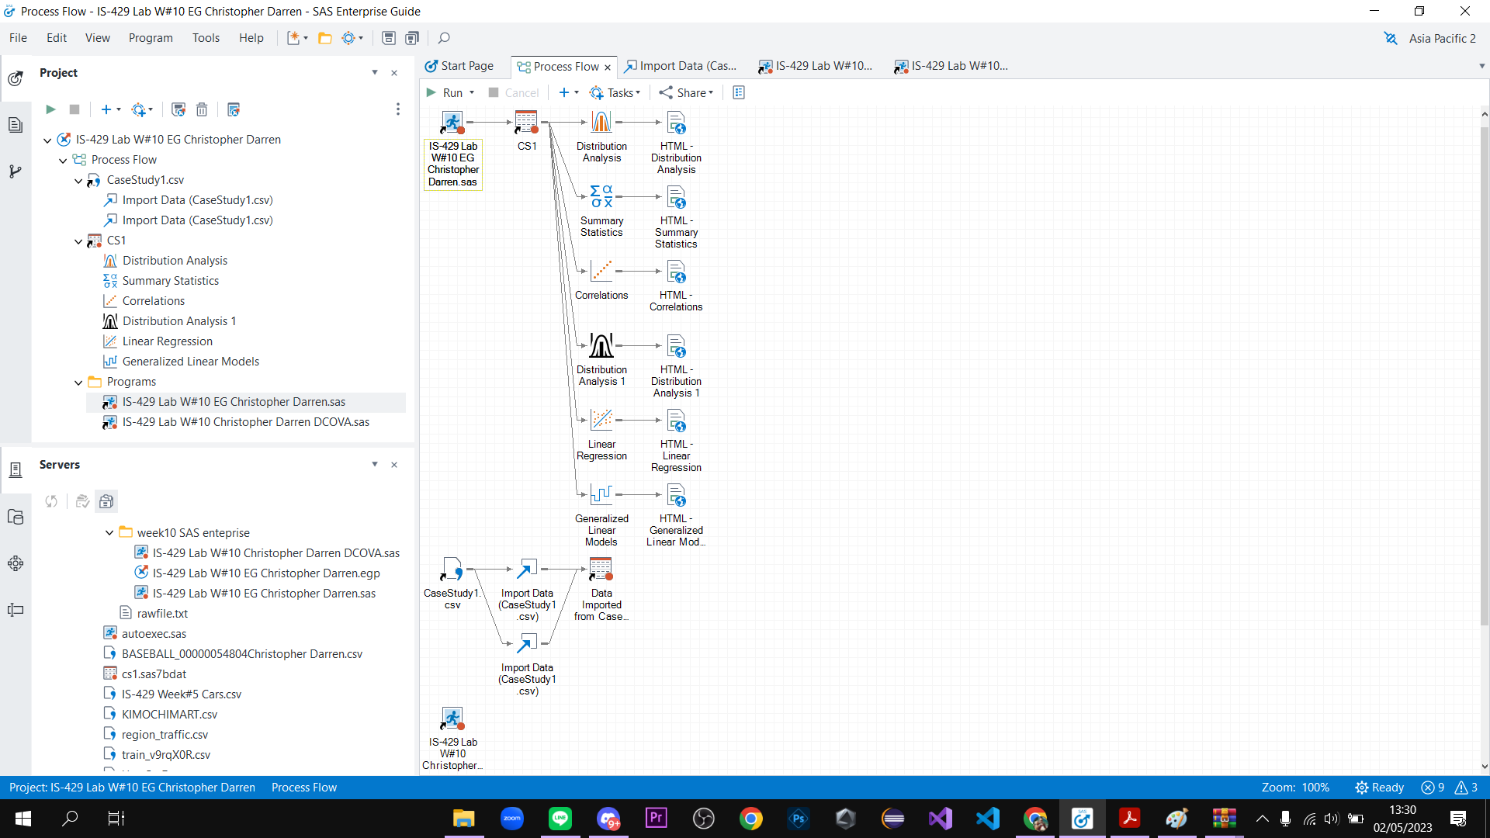

**E. Process Flows**